**EMPLOYEE PERFORMANCE MAPPING**

## ACTIONS

1. Create database employee;

use employee;

1. ER -DIAGRAM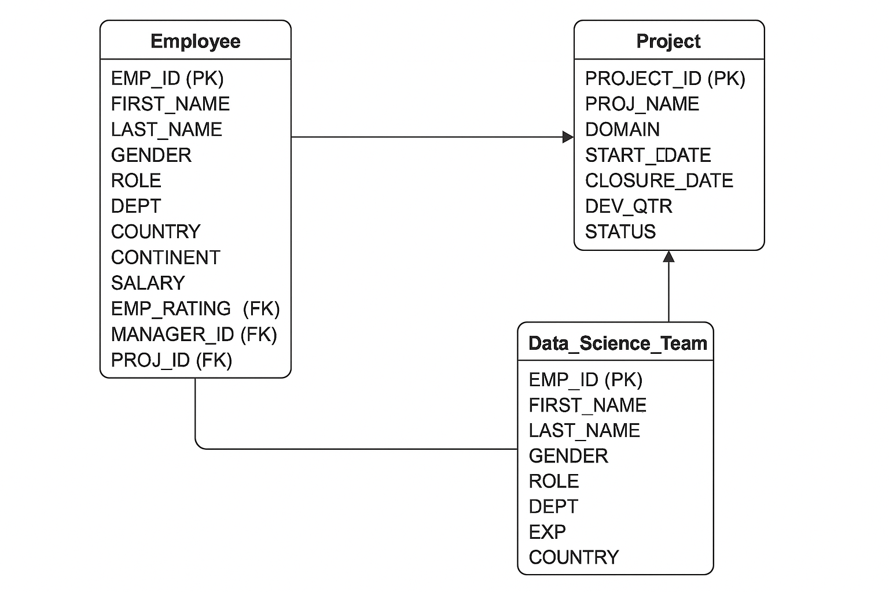
2. SELECT EMP_ID,FIRST_NAME,LAST_NAME,GENDER,DEPT from emp_record_table;

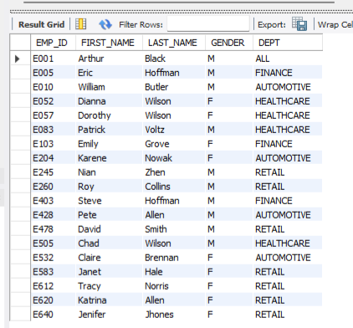

1. SELECT EMP_ID,FIRST_NAME,LAST_NAME,GENDER,DEPT,EMP_RATING from emp_record_table
   * + 1. WHERE EMP_RATING <2;

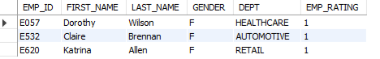

* + - 1. WHERE EMP_RATING >4;

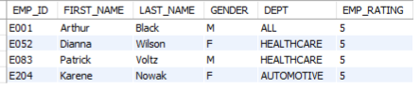

* + - 1. WHERE EMP_RATING BETWEEN 2 AND 4;

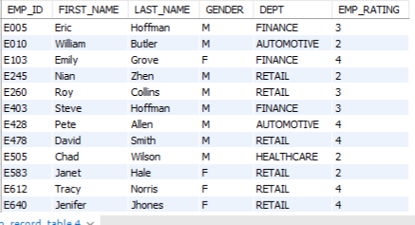

1. SELECT CONCAT(FIRST_NAME, " ",LAST_NAME) AS NAME FROM emp_record_table

WHERE DEPT='FINANCE';

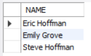

1. SELECT EMP_ID,FIRST_NAME,ROLE,DEPT FROM emp_record_table

WHERE ROLE IN('Manager','President','CEO');

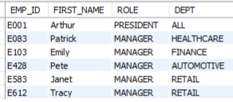

1. SELECT EMP_ID,FIRST_NAME,LAST_NAME FROM emp_record_table

WHERE DEPT='HEALTHCARE'

UNION

SELECT EMP_ID,FIRST_NAME,LAST_NAME FROM emp_record_table

WHERE DEPT='FINANCE';

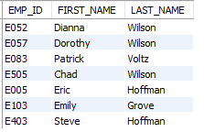

1. SELECT EMP_ID,FIRST_NAME,LAST_NAME,ROLE,e.DEPT,EMP_RATING,d.MAX_EMP_RATING FROM emp_record_table e

JOIN ( SELECT DEPT , MAX(EMP_RATING) AS MAX_EMP_RATING FROM emp_record_table

GROUP BY DEPT ) d

ON e.DEPT=d.DEPT;

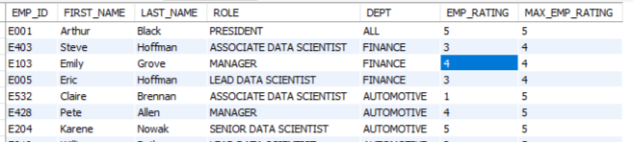

1. SELECT ROLE ,MAX(SALARY) AS MAX_SALARY , MIN(SALARY) AS MIN_SALARY FROM emp_record_table

GROUP BY ROLE;

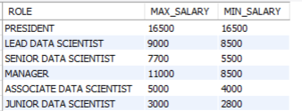

1. SELECT EMP_ID,FIRST_NAME,LAST_NAME ,EXP,RANK() OVER(ORDER BY EXP DESC) AS RANK_OF_EMP FROM emp_record_table;

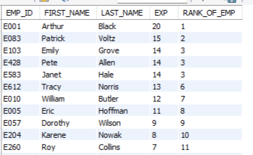

1. CREATE VIEW EMP_TABLE AS

SELECT * FROM emp_record_table

WHERE SALARY>6000;

SELECT * FROM EMP_TABLE;

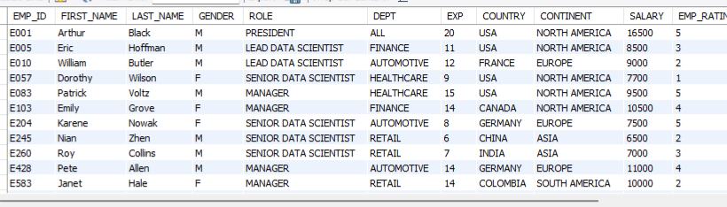

1. SELECT e.EMP_ID,e.FIRST_NAME,e.EXP

FROM emp_record_table e

WHERE e.EMP_ID IN(SELECT s.EMP_ID FROM emp_record_table s

WHERE s.EXP>10)

ORDER BY e.EXP DESC;

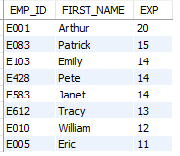

1. DELIMITER //

CREATE FUNCTION Get_Standard_role(exp int)

RETURNS VARCHAR(50)

DETERMINISTIC

BEGIN

DECLARE

ROLE VARCHAR(50);

CASE

WHEN exp<=2 THEN SET ROLE='JUNIOR DATA SCIENTIST';

WHEN exp<=5 THEN SET ROLE= 'ASSOCIATE DATA SCIENTIST';

WHEN exp<=10 THEN SET ROLE='SENIOR DATA SCIENTIST';

WHEN exp<=12 THEN SET ROLE='LEAD DATA SCIENTIST';

WHEN exp<=16 THEN SET ROLE='MANAGER';

ELSE SET ROLE ='OTHER';

END CASE;

RETURN ROLE;

END;

//

DELIMITER ;

SELECT EMP_ID,FIRST_NAME,LAST_NAME,ROLE,Get_Standard_Role(d.EXP) as EXPECTED_ROLE,

CASE

WHEN d.ROLE=Get_Standard_Role(d.EXP) THEN 'MATCH'

ELSE 'MISMATCH'

END AS STATUS

FROM data_science_team d;

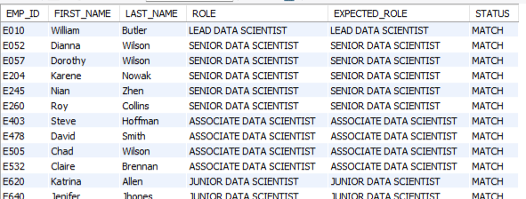

1. EXPLAIN SELECT * FROM emp_record_table WHERE FIRST_NAME='Eric';



CREATE INDEX EMP_FIRST_NAME ON emp_record_table(FIRST_NAME(50));

EXPLAIN SELECT * FROM emp_record_table WHERE FIRST_NAME='Eric';



1. SELECT * , (0.05*SALARY*EMP_RATING) AS BONUS FROM emp_record_table;

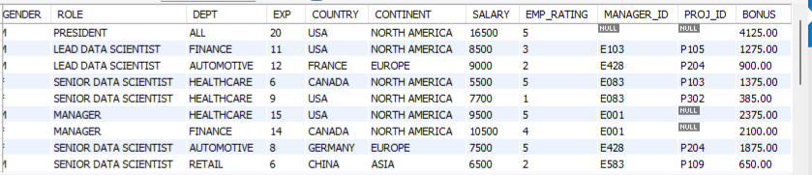

1. SELECT COUNTRY,CONTINENT , AVG(SALARY) FROM emp_record_table

GROUP BY 1,2;

